Full / Outer Join

Definition
# Source: AI Source: Provided by: [Data Path: Persons Table -> ID Column: 1, Name_En Column: Motasem Essam] -> From: [Chatgpt (GPT‑5 Mini)] on [12/10/2025]
A Full Join or Outer Join or Full Outer Join) is a data operation that combines two datasets by keeping all rows from both tables. If a row in one table does not have a matching key in the other table, the missing values are filled with NULL or NaN.

Key Idea
# Source: AI Source: Provided by: [Data Path: Persons Table -> ID Column: 1, Name_En Column: Motasem Essam] -> From: [Chatgpt (GPT‑5 Mini)] on [12/10/2025]
A Full Outer Join returns the union of two datasets, including all matched and unmatched rows from both tables.

How It Works
# Source: AI Source: Provided by: [Data Path: Persons Table -> ID Column: 1, Name_En Column: Motasem Essam] -> From: [Chatgpt (GPT‑5 Mini)] on [12/10/2025]
- Identify the common key column between the two datasets.
- Match rows based on the key.
- Include:
  - Rows that match in both tables
  - Rows that appear only in the left table
  - Rows that appear only in the right table
- Fill missing values with NULL/NaN.

Example
# Source: AI Source: Provided by: [Data Path: Persons Table -> ID Column: 1, Name_En Column: Motasem Essam] -> From: [Chatgpt (GPT‑5 Mini)] on [12/10/2025]
Dataset A – Customers
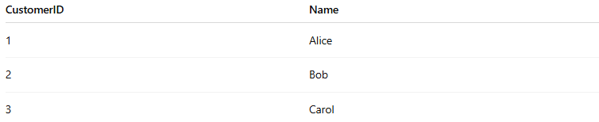
CustomerID | Name
1 | Alice
2 | Bob
3 | Carol
Dataset B – Orders
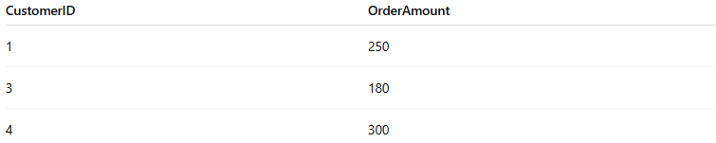
CustomerID | OrderAmount
1 | 250
3 | 180
4 | 300
Full Outer Join on CustomerID
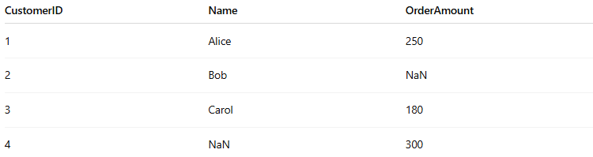
CustomerID | Name | OrderAmount
1 | Alice | 250
2 | Bob | NaN
3 | Carol | 180
4 | NaN | 300
- Customer 2 appears with no order → OrderAmount = NaN
- Order 4 appears with no customer → Name = NaN

Applications
# Source: AI Source: Provided by: [Data Path: Persons Table -> ID Column: 1, Name_En Column: Motasem Essam] -> From: [Chatgpt (GPT‑5 Mini)] on [12/10/2025]
- Combining datasets while preserving all information
- Detecting missing relationships between tables
- Data integration from multiple sources

Advantages
# Source: AI Source: Provided by: [Data Path: Persons Table -> ID Column: 1, Name_En Column: Motasem Essam] -> From: [Chatgpt (GPT‑5 Mini)] on [12/10/2025]
- Keeps all records from both datasets
- Useful for data completeness and exploration
- Helps identify unmatched records

Disadvantages
# Source: AI Source: Provided by: [Data Path: Persons Table -> ID Column: 1, Name_En Column: Motasem Essam] -> From: [Chatgpt (GPT‑5 Mini)] on [12/10/2025]
- May produce many NULL/NaN values
- Can increase dataset size significantly

